TONI PRECKWINKLE PRESIDENT, COOK COUNTY BOARD OF COMMISSIONERS  SISAVANH BAKER  DIRECTOR | COOK COUNTY BOARD OF ETHICS  69 W. WASHINGTON STREET, SUITE 1130  CHICAGO, ILLINOIS 60602  OFFICE 312/603-4304 - FAX 312/603-9988 | BOARD OF ETHICS MEMBERS  DR. SUSAN GAFFNEY  VON MATTHEWS, VICE CHAIR  ANTARA NATH RIVERA  HON. MARCUS SALONE THOMAS SZROMBA, CHAIR

PUBLIC NOTICE

Notice is hereby given of the scheduled in-person meeting of the Cook County Board of Ethics on Thursday, February 2, 2023, at 2:00 p.m.

The public can view this meeting virtually by visiting https://www.cookcountyil.gov/service/board-ethics-board-meetings-members on February 2, 2023. The public may provide notice of public comment to the Board by email at cookcounty.ethics@cookcountyil.gov or by phone at 312-603- 4304.
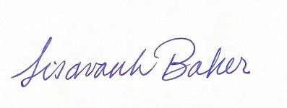

____________________
Sisavanh Baker, Director

