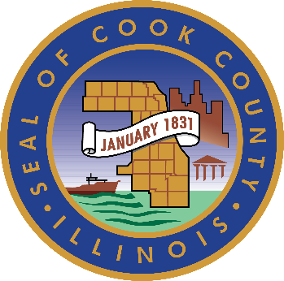
COOK COUNTY GOVERNMENT

Request for Information (RFI) for

Harrison Square Innovation Development Opportunity

October 15, 2026

Deadline for Questions:
Questions must be submitted by email no later than Thursday, October 22, 2026, at 12:00 p.m. Central Time
Response Due Date:
Responses must be submitted by email no later than Thursday, November 19, 2026, at 12:00 p.m. Central Time
Questions and Responses Must Be Submitted To:
BAMRFI@cookcountyil.gov

Executive Summary
The government of Cook County, Illinois (the County), is seeking information from developers, operators, investors, healthcare and life sciences institutions, research organizations, prospective users, and other interested parties regarding a potential innovative healthcare and biomedical development, or other innovative incubator space, within Harrison Square in the Illinois Medical District (IMD).
The County has intentionally not identified a preferred development concept and seeks market input regarding the opportunity. Prior market analysis identified demand for medical office and flexible clinical space within the IMD but did not identify demonstrated demand for additional conventional life sciences or laboratory space. At the same time, the IMD offers a significant concentration of healthcare institutions, clinical capabilities, research activity, and County-Controlled Property that may support a more targeted innovation opportunity.
Through this RFI, the County seeks market input regarding:
- The users and the unmet needs that the opportunity could serve;
- The ability to activate a parcel and provide scalable workspace and amenities to possible tenants, ranging from day work to long-term leases;
- Demand for medical office, flexible clinical, applied research, shared laboratory, medtech, digital health, commercialization, or complementary uses;
- Appropriate development scale, program, and phasing;
- Potential developer, operator, anchor, and institutional roles;
- Commercial, financing, ownership, and governance structures; and
- The public support or institutional commitments required for implementation.
The County welcomes candid, evidence-based feedback, including recommendations that challenge assumptions, identify market constraints, and suggest alternative concepts. Information received will help the County determine whether a viable opportunity exists and whether additional planning or procurement activities are warranted.
This RFI is issued solely for market research and planning and does not constitute a formal procurement nor is it a commitment by the County to undertake a project. Information received will help the County determine whether an actionable market opportunity exists and, if so, how it should be defined and advanced.

1. Definitions
For purposes of this RFI, the following terms have the meanings provided below.
County
The government of Cook County, Illinois.
Harrison Square
County-Controlled Property identified as Parcels 1, 2, 3, and 4, in the map in Figure 1, located adjacent to the Cook County Health Stroger Hospital campus within the Illinois Medical District and which may be considered for redevelopment.
Illinois Medical District (IMD)
The special-use medical district located on Chicago’s Near West Side that includes Cook County Health, Rush University Medical Center, University of Illinois (UI) Health, the Jesse Brown Veterans Affairs (VA) Medical Center, and other healthcare, research, education, and government institutions.
Innovation Development
A potential development that may include business incubator, co-working, or flexible workspaces. The development may be focused on healthcare or biomedical uses, such as medical offices; laboratories; clinical suites; or facilities to support research and development, medtech, digital health, or commercialization. The development could also offer entrepreneurial support, workforce development opportunities, community amenities, and activated public zones accessible to tenants and the broader IMD community.
Respondent
Any developer, operator, investor, healthcare institution, research organization, prospective user, nonprofit, university, or other entity submitting information in response to this RFI.
County-Controlled Property
Real property owned, leased, or otherwise controlled by the County.
RFI Contact
The individual designated by the County to receive questions and responses related to this Request for Information, as provided in Section 7.2.
RFI Schedule
The anticipated schedule provided in Section 7.1.
Addenda
Written clarification or modification issued by the County regarding this RFI, as noted in Section 7.3.

2. Introduction
Cook County invites developers, operators, investors, healthcare institutions, research organizations, prospective users, and other interested parties to provide input regarding a potential Innovation Development within Harrison Square and the Illinois Medical District.
The County is seeking practical, market-based, and viable development recommendations from organizations with experience developing, financing, operating, occupying, or supporting healthcare, research, innovation, and/or mixed-use developments.
The County has not selected a preferred use, program, site, scale, development model, or form of public sector financial or non-financial support. The County remains open to alternative concepts that are supported by market evidence.
The County is issuing this RFI to determine whether an actionable, market-supported innovation or incubator opportunity exists within Harrison Square and, if so, how that opportunity should be defined and advanced.
The County seeks information, outlined in Section 6, that will help it:
- Validate demand and identify prospective users;
- Identify unmet healthcare, clinical, research, commercialization, and workforce needs;
- Evaluate potential uses, development concepts, sites, scale, and phasing;
- Define potential roles for Cook County Health and other institutional partners;
- Identify potential developers, operators, investors, anchors, and users;
- Evaluate ownership, governance, operating, financing, and delivery models;
- Determine the public participation or institutional commitments required for feasibility;
- Identify major market, financial, operational, regulatory, and implementation risks; and
- Determine whether additional analysis or a future procurement is warranted.
Respondents are encouraged to provide candid, evidence-based feedback, including identifying concepts that are not currently feasible, conditions that would need to be satisfied before implementation, and alternatives that may better achieve the County’s objectives.

3. Harrison Square Development Opportunity Overview

3.1 Development Opportunity Overview
To support its evaluation of whether Harrison Square could support an Innovation Development, the County welcomes recommendations regarding the development program, scale, phasing, ownership structure, and implementation strategy that are best supported by market conditions. See Figure 1 below for details on the site’s existing conditions. The County has a preference for an Innovation Development on Parcel 2; however, it remains open to concepts on Parcels 1, 2, 3, and/or 4.
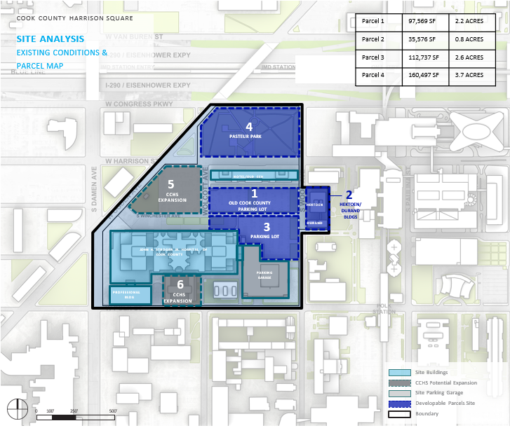
Figure 1: Existing Conditions and Parcels
The County envisions that potential uses may include medical office, flexible clinical space, applied research, shared laboratory facilities, medical technology, digital health, commercialization support, workforce development, and complementary uses; however, Respondents may recommend other concepts supported by market evidence and relevant experience.
The County is particularly interested in development concepts that:
- Address a demonstrated need within the IMD or broader regional market;
- Leverage Cook County Health and other institutional capabilities;
- Complement rather than duplicate existing facilities and programs;
- Support phased and financially sustainable implementation;
- Attract institutional and private-sector participation; and
- Limit the County’s long-term financial and operating exposure.
To support informed responses, the County has provided relevant site maps, parcel information, and existing-condition materials in Figures 1-4, and additional reference materials in the Appendix in Section 9.

3.2 Potential Strategic Advantages
Respondents are encouraged to assess how the following attributes could contribute to a viable development concept:
- Location and Access. Harrison Square is located within Chicago and is served by interstate highways, Chicago Transit Authority (CTA) rail and bus service, and regional transportation connections in close proximity such as Union Station, Ogilvie Station, and LaSalle Street Station providing both Metra and Amtrak service. Respondents are encouraged to evaluate how accessibility, surrounding land uses, and connections to nearby institutions affect the area’s attractiveness to prospective users, employers, employees, patients, and partners. See Figure 2 below for details on site accessibility and circulation.
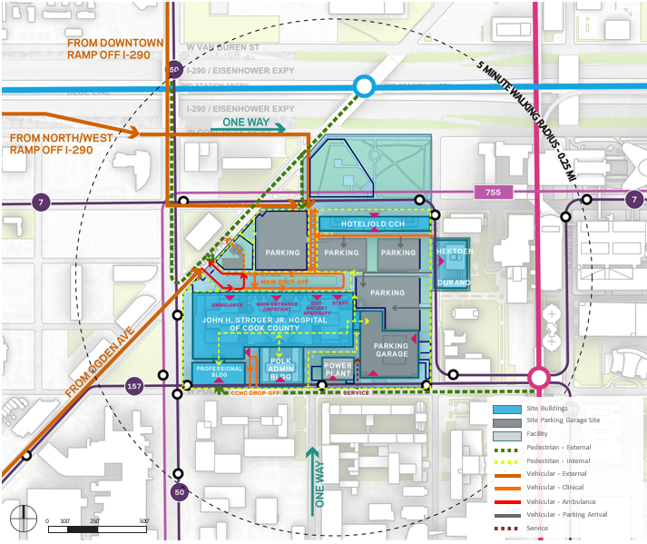
Figure 2: Site Access and Circulation
- Healthcare and Institutional Concentration. The IMD includes Cook County Health, Rush University Medical Center, UI Health and UIC, the Jesse Brown VA Medical Center, and other healthcare, education, and research organizations. This concentration may create opportunities for clinical partnerships, research collaboration, workforce development, commercialization, and shared services. Respondents are encouraged to identify the specific commitments and partnerships required to realize these opportunities.
- Cook County Health Capabilities. Cook County Health’s clinical operations, diverse patient population, workforce, and institutional relationships may provide a differentiated platform for applied research, clinical validation, healthcare delivery innovation, and workforce development. Respondents are encouraged to assess the appropriate role for Cook County Health and any operational, regulatory, or governance considerations.
- County-Controlled Property. County-Controlled Property within Harrison Square may provide flexibility to consider long-term ground leases, phased development, public-private partnerships, or other delivery structures. Respondents are encouraged to evaluate how public ownership could support implementation while protecting the County’s long-term interests.
- Surrounding Development. Existing and planned development within and near the IMD may provide complementary housing, hospitality, retail, and other amenities. Respondents are encouraged to assess whether and how these investments enhance the feasibility or positioning of the Harrison Square opportunity.

4. Background

4.1 Cook County’s Role in Healthcare and Innovation
Cook County supports healthcare delivery, workforce development, research partnerships, and economic development through Cook County Health and other County programs and investments.
Cook County Health operates a major public health system serving a diverse patient population through hospitals, outpatient facilities, and community-based services. Its location within the Illinois Medical District creates opportunities for collaboration with Rush University Medical Center, UIC and UI Health, the Jesse Brown VA Medical Center, and other healthcare, academic, and research institutions.
The County is evaluating whether its clinical capabilities, institutional relationships, and available property could support a targeted Innovation Development. Potential areas of focus may include applied and translational research, clinical validation, medical devices, digital health, flexible clinical or medical office space, commercialization support, and workforce development. The County has not determined which activities, users, or facilities should be prioritized.

4.2 Harrison Square Development Context
Harrison Square is located near other major redevelopment initiatives that may influence the area’s future mix of uses, amenities, access, and investment.
The 1901 Project is a planned mixed-use redevelopment surrounding the United Center that is expected to include residential, commercial, hospitality, entertainment, and public-space components. Although it differs significantly from the opportunity under consideration at Harrison Square, Respondents may consider whether the 1901 Project could affect surrounding development patterns, infrastructure, amenities, or talent attraction. See Figure 3 below for details on nearby projects and site positioning.
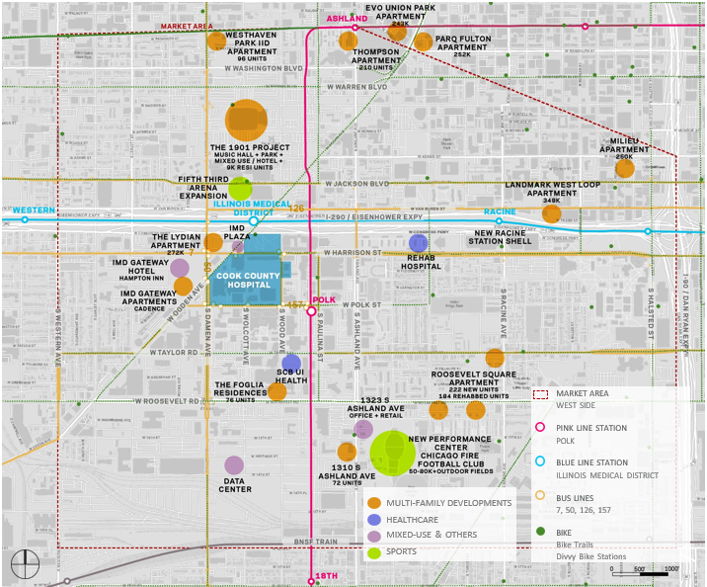
Figure 3: Site Context
The IMD Gateway project has introduced additional retail, residential, and hospitality uses near Harrison Square. Its components include Gateway Retail, Cadence Apartments, and the Hampton Inn & Suites. These investments provide additional amenities for patients, residents, employees, and visitors within the IMD.
Respondents are encouraged to consider how existing and planned surrounding development may affect the positioning, complementary uses, phasing, and long-term implementation of a Harrison Square Innovation Development. These developments are provided as context and should not be interpreted as evidence of demand for a particular use.

4.3 Illinois Medical District (IMD)
The Illinois Medical District is a special-use district on Chicago’s Near West Side containing a significant concentration of healthcare, education, research, and public institutions. Major anchors include Cook County Health, Rush University Medical Center, UI Health and the University of Illinois Chicago (UIC), and the Jesse Brown VA Medical Center. These institutions provide clinical capabilities, research activity, educational programs, specialized talent, and potential opportunities for collaboration. See Figure 4 below for details on the surrounding IMD landowners and adjacent public transportation infrastructure.
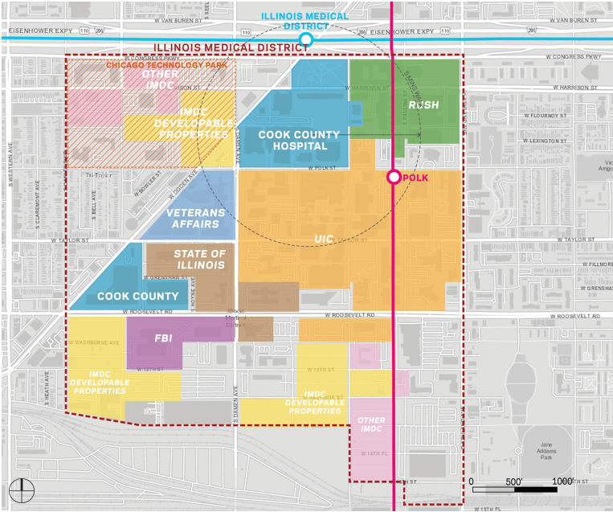
Figure 4: IMD Landowners and Key Stakeholders
The feasibility of an Innovation Development will depend on demonstrated user demand, institutional commitments, a differentiated market position, and a sustainable operating and financial model.

4.4 Broader Chicago Healthcare and Innovation Ecosystem
Harrison Square and the IMD are situated within Chicago’s broader innovation ecosystem, which includes life sciences, healthcare, technology, investment, and commercialization activity across the city.
Relevant facilities and innovation platforms include:
- The Chicago ARC ecosystem, which includes relationships with Cook County Health and UIC and focuses on healthcare innovation and health equity;
- UIC’s Technology Innovation Lab, which provides shared wet and dry laboratory facilities, coworking space, and programming for early-stage technology and life sciences companies;
- MATTER, which supports healthcare entrepreneurship and connects startups with healthcare and industry partners;
- Rush University Medical Center’s Chicago Area Patient-Centered Outcomes Research Network (CAPriCORN), which supports clinical research and data collaboration among healthcare institutions; and
- UIC’s planned Drug Discovery and Cancer Research Pavilion, an approximately 188,000-square-foot facility that will support drug discovery and cancer research and bring together UIC researchers, students, and industry partners. The project is advancing through a State design-build procurement with an identified budget of approximately $198 million.
These existing and planned investments offer potential partnership opportunities while reinforcing the need for Harrison Square to establish a distinct market role.

4.5 Current Market Conditions
Healthcare and life sciences real estate markets have changed considerably in recent years. Higher construction and financing costs, laboratory vacancies in some markets, changing venture capital investment patterns, and greater scrutiny of speculative development have increased the importance of demonstrated demand, committed users, disciplined phasing, and sustainable operating models.
Prior analysis identified potential demand for medical office and flexible clinical space within the IMD but did not establish demonstrated demand for additional conventional life sciences laboratory space. Respondents are encouraged to test these findings using current market evidence and relevant project experience.

5. Project Vision and Desired Outcomes

5.1 Potential Development Program
The County is open to a range of innovation and incubator concepts, including those in the healthcare and biomedical space. Potential uses may include medical office, flexible clinical space, applied or translational research, shared laboratories, medical device and diagnostics space, digital health, commercialization programs, workforce development, and complementary uses.
Respondents are encouraged to recommend development concepts that best achieve these objectives and identify the partnerships, commitments, and market conditions necessary for success.

5.2 Development Goals
Although the County has not identified a preferred development concept, any future opportunity should:
- Respond to demonstrated market demand;
- Complement existing healthcare, research, and innovation assets;
- Support sustainable economic and workforce development;
- Attract institutional and private-sector investment; and
- Be supported by a financially sustainable implementation strategy that protects the County's long-term interests.

5.3 Site and Phasing
The County is open to considering a development concept on Parcels 1, 2, 3, and/or 4 at Harrison Square, as shown in Figure 1. Parcel 2, currently the site of the Hektoen and Durand Buildings, is of particular interest for this development concept. The County intends to demolish, at its cost, the Hektoen and Durand buildings, thereby providing a clear site for potential development.
The County is also interested in whether a minimum viable first phase could reduce risk and allow a development to expand as demand and partnerships mature.

5.4 Ownership, Delivery, and Operations
The County has not selected a preferred ownership, delivery, governance, or operating model. Potential approaches could include a long-term ground lease, public-private partnership, joint venture, developer-led project, institutional partnership, nonprofit structure, or another Respondent-recommended model.

5.5 Public Sector Participation
The County has not determined whether public sector participation will be necessary or appropriate. Potential support could include land, infrastructure, incentives, grants, tenancy, or other financial or non-financial participation.

5.6 Illustrative Development Examples
The projects below illustrate the types of innovation, incubator, and mixed-use development concepts that the County finds informative. These examples are intended to provide context and inspiration rather than prescribe a preferred development model, program, scale, or use. The County welcomes creative, market-driven ideas and encourages Respondents to recommend alternative concepts that are well-suited to the site and its surrounding context.
- Catalyst Omaha: A 170,000-square-foot innovation hub anchored by the University of Nebraska Medical Center’s 41,000-square-foot Innovation Hub and featuring flexible office and coworking space, meeting and event venues, and publicly accessible food, retail, and community amenities.
- Massachusetts Institute of Technology (MIT) Kendall Square Initiative: A 1.8 million-square-foot mixed-use research and innovation district developed on former MIT-owned parking lots, integrating research and development, residential, office, retail, and public open space to create an active, campus-connected innovation ecosystem.
- 16 Tech Innovation District: A 50-acre innovation district in Indianapolis that brings together life sciences, advanced manufacturing, research institutions, startups, and surrounding neighborhoods through a mix of laboratory, office, manufacturing, coworking, retail, residential, and public gathering spaces.

6. Response Requirements

6.1 Response Components
Responses should include:
- A signed cover letter identifying the Respondent’s organization, relevant experience, and potential role in the opportunity;
- An executive summary; and
- Responses to the questions and requests in Section 6.2.
Respondents may choose to submit supporting market information, such as conceptual plans, financial analyses, and case studies, as appendices, if applicable. See Section 6.3 for page limits.

6.2 Response Questions and Requests
The County seeks concise, evidence-based responses reflecting each Respondent’s experience, recommendations, and potential interest in the opportunity. Respondents should address questions relevant to their anticipated role and proposed development concept, as well as note any questions or requests that they are not positioned to answer.
Organization, Experience, and Interest
- Describe your current level of interest and the additional information or conditions required to advance that interest.
- Provide up to five (5) comparable projects, including their development and operating models, financing structures, key partners, current status, and relevant lessons learned.
Market Assessment and Opportunity
- What healthcare, clinical, research, innovation, commercialization, or complementary needs are currently unmet within the IMD or broader Chicago market?
- Which prospective tenants, partners, and activities present the strongest near- and long-term opportunities for Harrison Square, and what evidence supports your assessment?
- What scale and mix of uses could the market support? Distinguish among components that could proceed now, those requiring an anchor or institutional commitment, and those that may become viable in later phases.
- What are the principal market risks, and are there concepts the County should not pursue under current conditions?
Development and Operating Strategy
- What development concept, building program and initial scale do you recommend, and which County-controlled parcel(s) best supports it?
- Should the concept be developed as a stand-alone project, as part of a broader mixed-use development, or through another approach?
- How could the development concept connect physically and/or programmatically with Cook County Health and other IMD institutions?
- What infrastructure, building systems, equipment, and operational capabilities are necessary for the development concept? Which elements, if any, could be phased or deferred?
Financial and Commercial Structure
- What ownership, governance, delivery, financing, and operating structure do you recommend, particularly if the County retains ownership of the land?
- What revenue, occupancy, preleasing, tenant-credit, anchor, or other commitments, if any, would be required to support development and ongoing operations?
- What County support would be required and why, and what private or institutional commitments should be secured in return?
Additional Recommendations
- Identify any emerging trends, lessons from comparable developments, alternative concepts, or other considerations that should materially influence the County’s approach.

6.3 Response Length
Responses shall not exceed twenty-three (23) pages total, excluding the cover letter and appendices, allocated as follows:
- Executive summary: not to exceed three (3) pages
- Responses to Section 6.2 questions: not to exceed twenty (20) pages
Respondents should prioritize concise, relevant, and evidence-based information.

6.4 Response Format
Responses should be submitted as searchable PDFs, should include page numbers, and should be written using twelve (12)-point Times New Roman or Arial font. Respondents should organize their submission according to the components outlined in Section 6.1, identify relevant assumptions, and note questions that are not applicable to their role.

7. RFI Information

7.1 RFI Schedule
The County may modify these dates through written Addenda.
- Question Due Date: Thursday, October 22, 2026, at 12:00 p.m. Central Time
- Question Response Date from the County (if any): Posted on or before Thursday, October 29, 2026, at 12:00 p.m. Central Time
- RFI Response Due Date: Thursday, November 19, 2026, at 12:00 p.m. Central Time
- Optional Interviews or Market-Sounding Sessions: On or before Friday, December 18, 2026

7.2 RFI Contact
All questions and RFI Responses must be directed to:
Name: Lawrence Brozek
Department: Cook County Bureau of Asset Management
Email: BAMRFI@cookcountyil.gov
Only written communications issued by the RFI Contact will be considered official.

7.3 Questions and Addenda
Questions regarding the RFI must be submitted in writing to the RFI Contact by the Question Due Date specified in Section 7.1, with the email subject line Harrison Square RFI Questions. The County may issue responses, clarifications, or modifications through written Addenda.
If the County issues responses to submitted questions, such responses will be posted by the Question Response Date specified in Section 7.1, on the Cook County Open Calls website (www.cookcountyil.gov/content/open-calls-bureau-asset-management). It is the sole responsibility of potential Respondents to monitor this location for updates, Addenda, and other communications related to this RFI.

7.4 Submission Method
RFI Responses must be submitted electronically to the RFI Contact via email by the RFI Response Due Date identified in Section 7.1, with the email subject line Harrison Square RFI Response.

8. RFI Process and Conditions

8.1 Nature of This RFI
This RFI is issued solely for market research and planning. It is not a Request for Qualifications (RFQ), Request for Proposals (RFP), invitation for bids, or other competitive solicitation and does not create a contractual relationship between the County and any Respondent.
Participation, nonparticipation, or the content of a response will not create an advantage, disadvantage, preference, or prerequisite for any future procurement. Nothing in this RFI obligates the County to undertake a project or issue a future solicitation.

8.2 Review and Use of Responses
Responses will not be scored, ranked, or used to establish a shortlist. The County may use the information received to inform planning, further analysis, project definition, and potential future procurement documents.
The County may request clarifications or supplemental information and may conduct optional interviews or market-sounding sessions. Participation in these activities will not provide an advantage in any future procurement.

8.3 Restricted Communications
During the open RFI period, all communications concerning the RFI must be directed to the RFI Contact. Respondents may not communicate regarding the RFI with County Commissioners, elected officials, County employees involved in the RFI, or consultants assisting the County unless expressly authorized.

8.4 Confidentiality and Freedom of Information Act
Responses are subject to the Illinois Freedom of Information Act, 5 ILCS 140, and other applicable law. Information may be publicly disclosed unless it qualifies for a statutory exemption.
Respondents requesting confidential treatment must identify the applicable information, cite the claimed exemption, explain the basis for the request, and submit a separate redacted response. The County will determine whether information qualifies for protection.

8.5 Reservation of Rights
The County reserves the right to amend or cancel this RFI, modify the schedule, request additional information, conduct follow-up discussions, or determine that no project or future procurement will proceed.

8.6 Cost of Response and No Contract
Respondents are responsible for all costs associated with participating in this RFI. Submission of a response or participation in follow-up discussions does not create a contract, promise, entitlement, or other obligation between the County and a Respondent.

8.7 Ownership of Submitted Materials
Responses, including supporting materials, submitted to the County will become County records and may be retained, used, reproduced, or referenced to the extent permitted by applicable law.

9. Appendix

9.1 Reference Materials
IMD Master Plan
Cook County Health Strategic Plan 2026-2028

