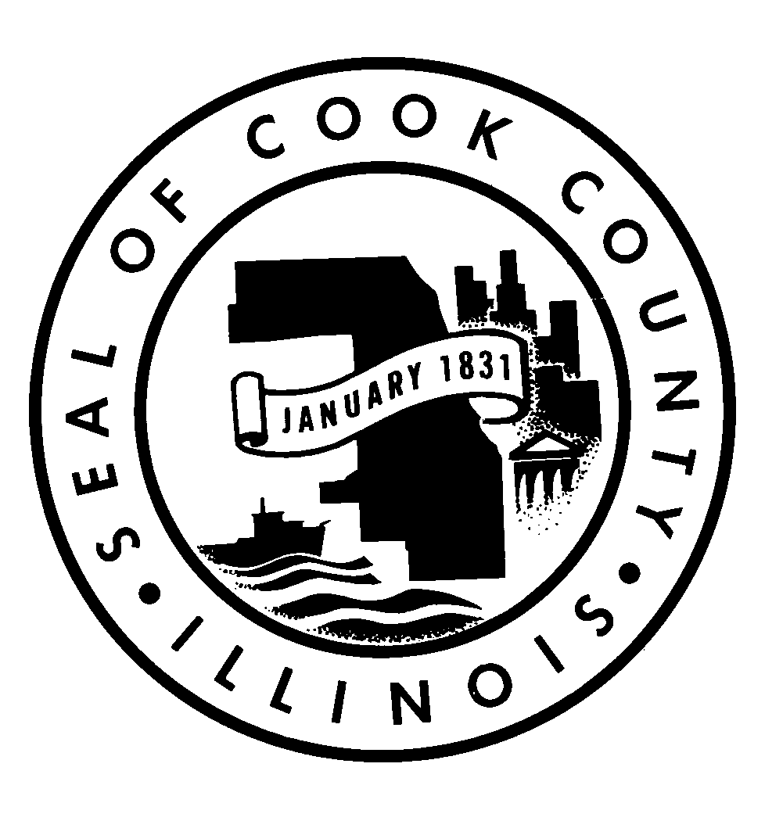
OFFICE OF THE
JUSTICE ADVISORY COUNCIL, COOK COUNTY, ILLINOIS
69 W. WASHINGTON STREET, SUITE 1110
CHICAGO, ILLINOIS 60602
TELEPHONE 312-603-1133
FACSIMILE 312-603-9974

AGENDA
Meeting of the Justice Advisory Council
_____________________________________________
January 8, 2016
8:30 am-10:00 am
69 W. Washington, 17th Floor Conference Room
Chicago, IL 60602

- Call to Order (Justice Burke)

- Remarks (President Preckwinkle)
- Review of Minutes

- Executive Director’s Report

- Criminal Justice Updates

- Juvenile Justice Updates

- Council Discussion

- New Business

- Public Comments

- Adjournment

